**Technical Interview**

Create a functional login page. Design should be single page and mobile friendly. It needs to use JWT tokens for authentication and use GraphQL in your API. This is only a login page so sample data can be directly entered in the database. Once logged it needs to go to a new screen that shows full name and country the user belong to.

Tech Stack

* ReactJS
* NodeJS
* PostgreSQL
* GraphQL
* Html
* CSS

**Frontend**

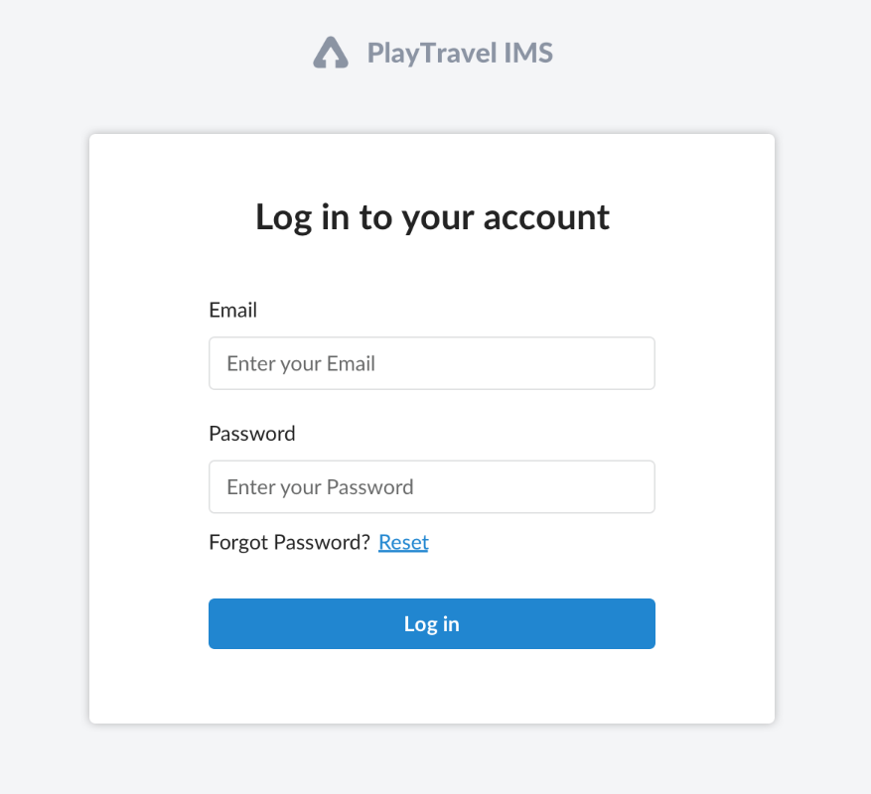

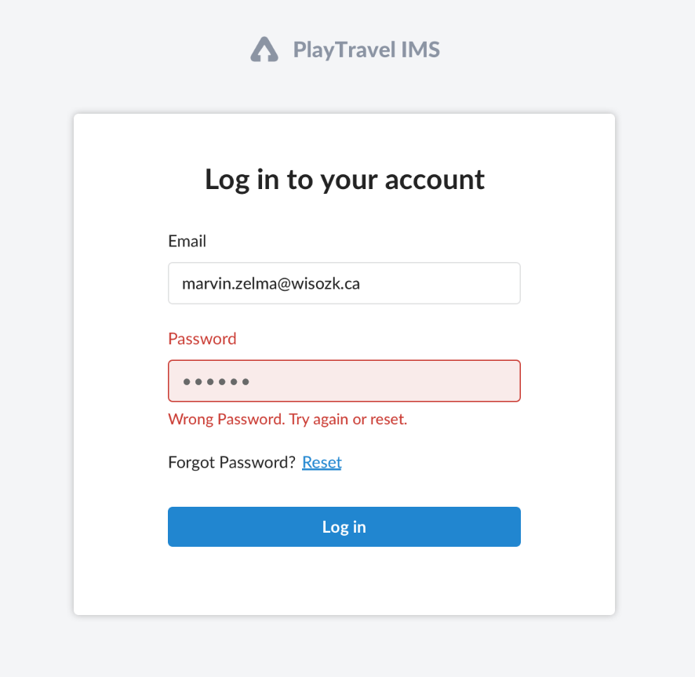

**Database design for users**

